**FORMAN CHRISTIAN COLLEGE (A CHARTERED UNIVERSITY)**

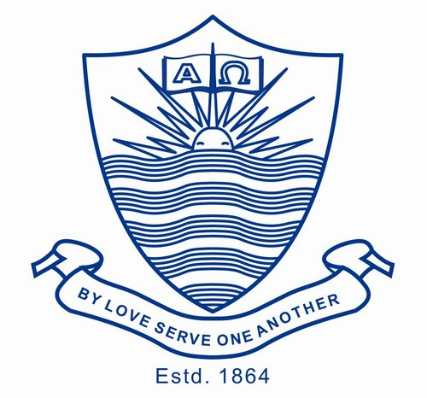

**Technology Management**

**SECTION A**

**Name: Hadi Hassan (Project Manager)**

**Roll No: 231469272**

Trello is the ultimate project management tool. Start up a board in seconds, automate tedious tasks, and collaborate anywhere, even on mobile.

Firstly we have to make a board which can be made by simply clicking on create board on which we custom template of our desired project with different cards in it on which we can represent phases of our projects on different interval of time. For example if we are working on website development so our cards can be like “to-do-list, doings, done and the last will be test run/review”. The best feature of this tool is we can check the phase of our project at any stage.

Cards comes with the different feature .i.e. Tag labeling with different colors for identification purpose of task. Secondly we can drag our task from one card (to-do list) to another card (doing) or etc. We can set reminder of a due date to intimate task before deadline by email. It can also share a notification email to every member on task completion or even on minor progress of the project.

Another distinguish feature of this tool is where we can upload our important file to each task in the form of attachment.

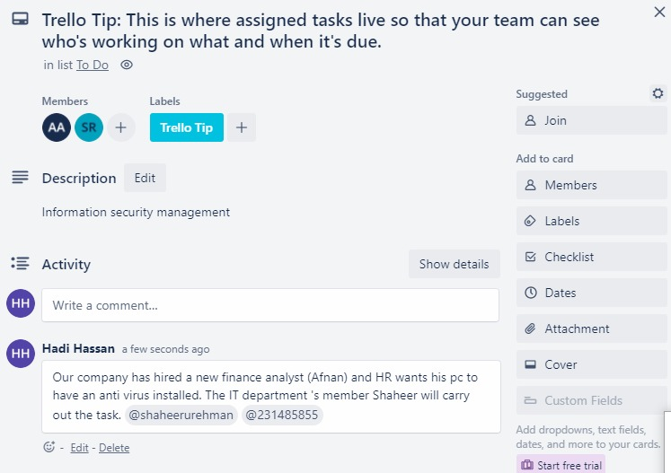

In this scenario an issue has been generated by the manager named @Hadi Hassan and task assigned to the concerned person of it department @ shaheerurehman.

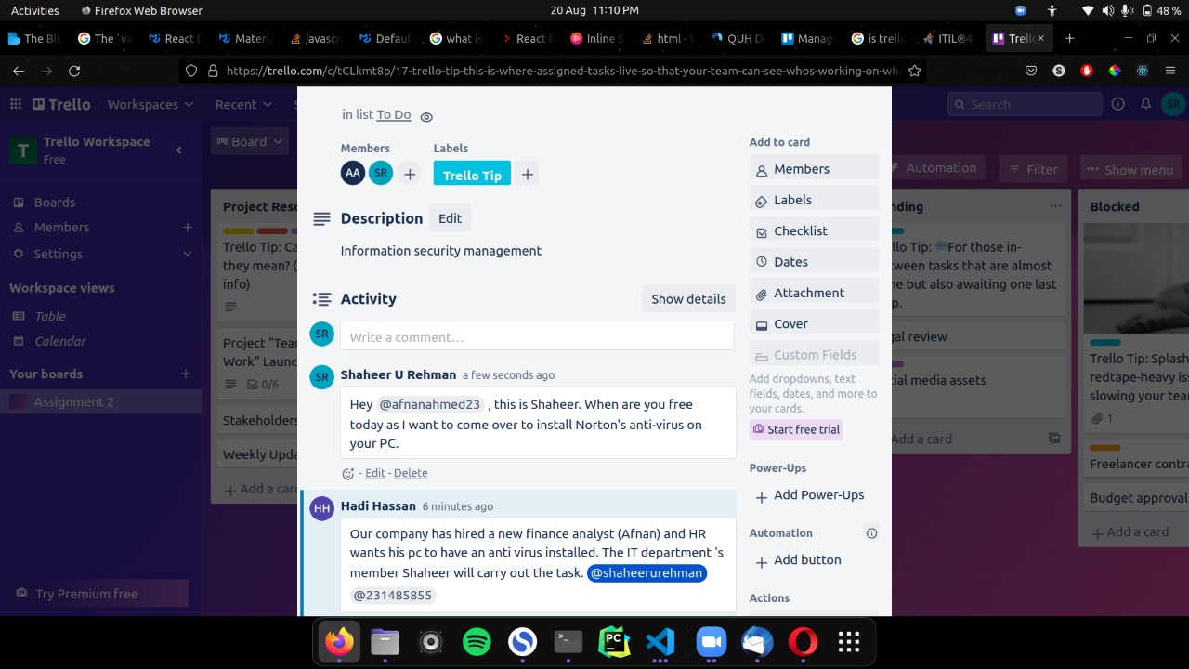

In this Picture we can see that the concerned person (Shaheer U Rehman) has seen the notification and respond back to schedule the time when will be Mr Afnan easy to resolve the issue by installing Norton ‘s antivirus.

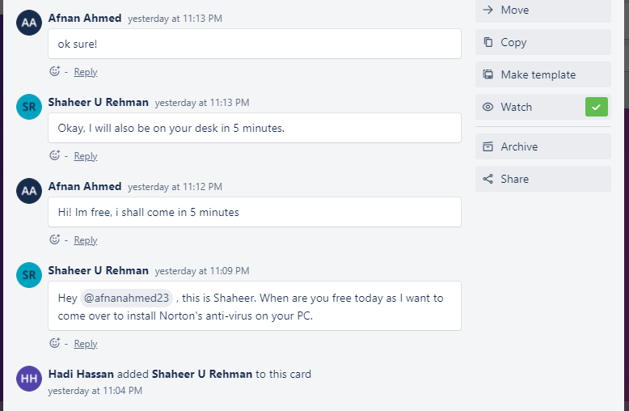

Here they have aligned to meet at Mr Afnan office in five minutes to install the demanded software.

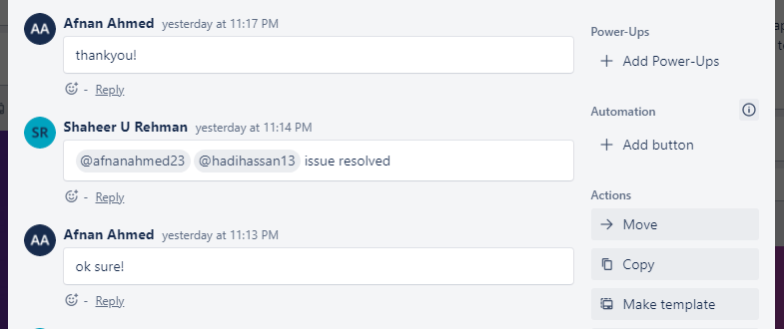

Now Mr Shaher u Rehman has installed the software and messaged as issue resolved in task where every person of the group can easily be notified of task completion.

**Continual Improvement.**

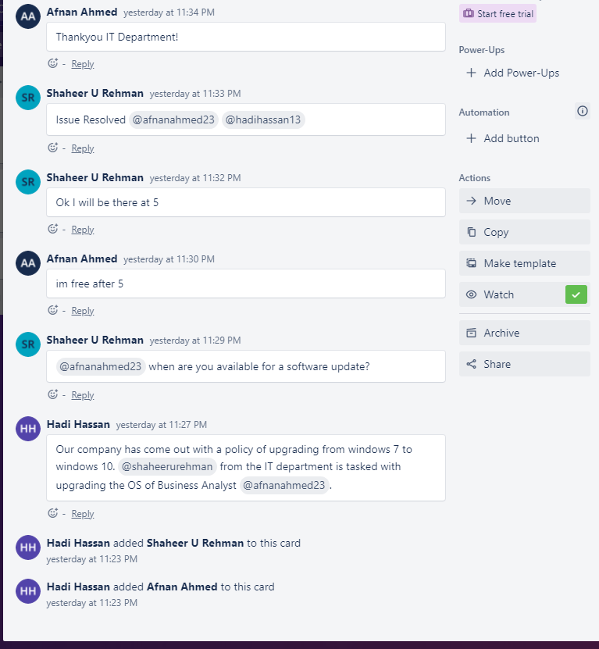

In this task we can see that a new assignment has been assigned to IT department Mr Shaheer U Rehman to upgrade window form 7 to 10 of Mr Afnan by Hadi Hassan on the basis of **Continual Improvement.**

Then they have aligned with each other with the updated software and time of meeting to update windows.

The message has been forwarded to the card of task completion where every member can easily see.

Notification is generated of task completion and whole thread of task can be seen by every concerned person with the time taken for completion.